K.J.Somaiya College Of Engineering,Mumbai -77

(Autonomous College Affiliated to University of Mumbai)

Department of Computer Engineering

Rubrics for Project A Progress Seminar

Category | Excellent(5) | Good(3-4) | Average(2) | Poor(<1)
 | Content is well | The overall | Content is logically | There was no clear
Organization | organized as per | organization of topics | organized for the | or logical
Organization | the guidelines | appears flawed. | most part. | organizational
 |  |  |  | structure, just lots of
 |  |  |  | facts.

Content

Contents were appropriate for the defined scope

Covers topic in-depth with details

Contents are appropriate but not in depth

Includes essential | Content is minimal
information about
the topic

 | All team members | All Team members | All team members | All team members
 | present. | present | present | not present
Team work and |  |  | No co-coordination
Project | Good co-ordination | Good co-coordination | No co-coordination | No co-coordination
Management |  |  | and no time | and no time
Management |  |  | management | and no time
 | Time management | No Time | management | management
 |  | management

Innovation in the Design Solution and self-study (For proposed System)

Analysis and solving skills

Inclusion of suggestions(Given at the time of approval seminar)

Frequency of reporting

New concepts used | Self-study of new | Superficial usage of | Basic concepts used
frequently | concepts / technique, | new concepts | correctly
 | with good | Self-study of new | Lack self-study, but
Self-study of new | understanding | technique, with | apply previously
technique and | Minor innovative | basic understanding | taught technique on
technique and | work |  | a satisfactory level
solve technical | work |  | a satisfactory level
difficulties;
Innovative work
Provide solution to | Complete solution | Simple, yet mostly | Obvious solution,
complex problems; | with nontrivial | complete solution | sketchy
Solution optimize | functionalities that | that solves the stated | functionalities
Solution optimize | meet the desired | problem
desired needs | meet the desired | problem
desired needs | needs
All suggestions | All suggestions are | Some suggestions | No suggestion
included in detail. | included in less | are included in | included
 | detail. | detail.
All weeks | Once in two weeks | Once in three weeks | Once in a month

K.J.Somaiya College Of Engineering,Mumbai -77

(Autonomous College Affiliated to University of Mumbai)

Department of Computer Engineering

Project-A Progress evaluation sheet (20-21)

Project Group No C15

Title of Project Kisaan Bandhu : A Farmer Grain Assistant Application

Roll No | Name | Signature
1711005 | Meet Bhanushali | 
1711038 | Govinda Patel | 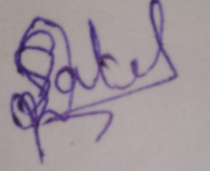
1711055 | Parth Sheth | 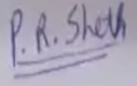
1711061 | Shailesh Upadhyay | 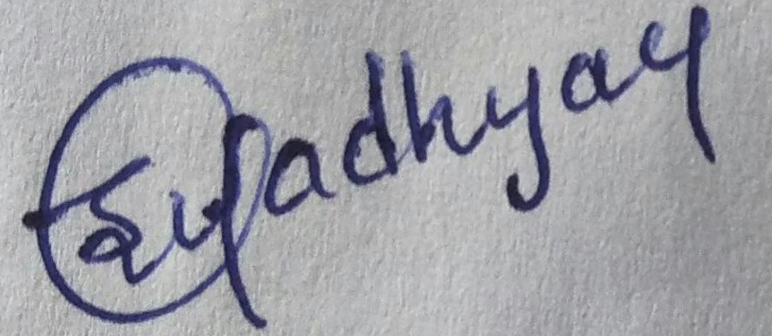

 |  |  | Innovation in the
Roll No | Organization | Team work and | Design Solution
Roll No | & Contents | Project | and self- study (5)
 | (5) | Management (5)

Analysis | Inclusion of
and | Inclusion of
and | suggestions | Total (25)
solving | suggestions | Total (25)
solving | and frequency
skills (5) | and frequency
skills (5) | of reporting
 | (5)

Project Mentor Name and Signature with date

Expert name and signature with date

